**INPUTS AND OUTPUTS**

**NOTE: All inputs are fed keeping in mind that matrix is 4X4 matrix and indexing starts from 0. Matrix of higher order can also be used by doing slight changes in the code.  
So for NXN matrix domain set becomes {0, 1, 2, ……, N-1}**

# **CASE-1: Neither Poset nor Lattice**

Input- (0,0), (1,1), (2,2), (3,3), (0,1), (1,0), (0,2), (0,3), (1,2), (1,3), (3,1), (2,3)

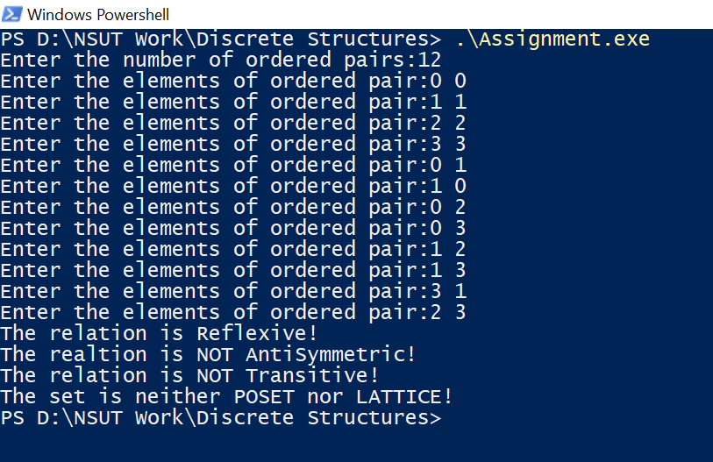

# **CASE-2: Poset but not Lattice**

Input- (0,0), (1,1), (2,2), (3,3)

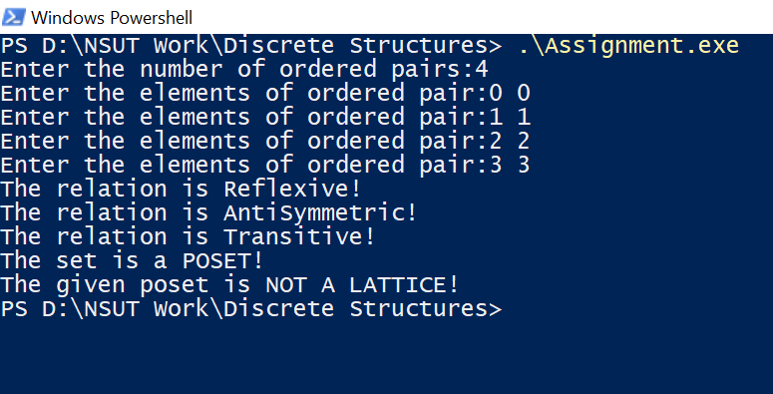

# **CASE-3: Lattice**

Input- (0,0), (1,1), (2,2), (3,3), (0,1), (0,2), (0,3), (1,2), (1,3), (2,3)  
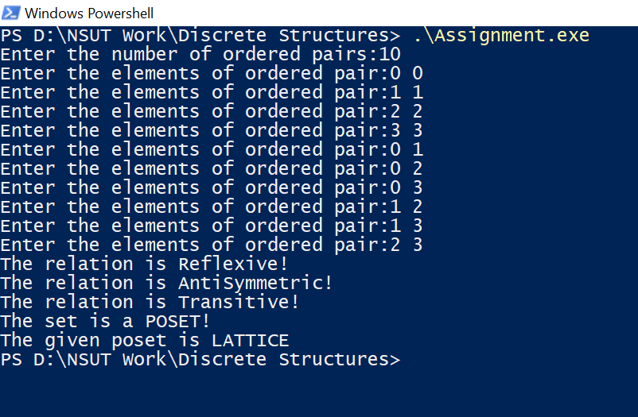

# **CASE-4: Random Input**

Input- (0,0), (1,1), (2,2), (3,3), (0,1), (0,2), (0,3), (1,2), (1,3), (2,3), (3,2), (3,1), (2,1), (3,0), (2,0)  
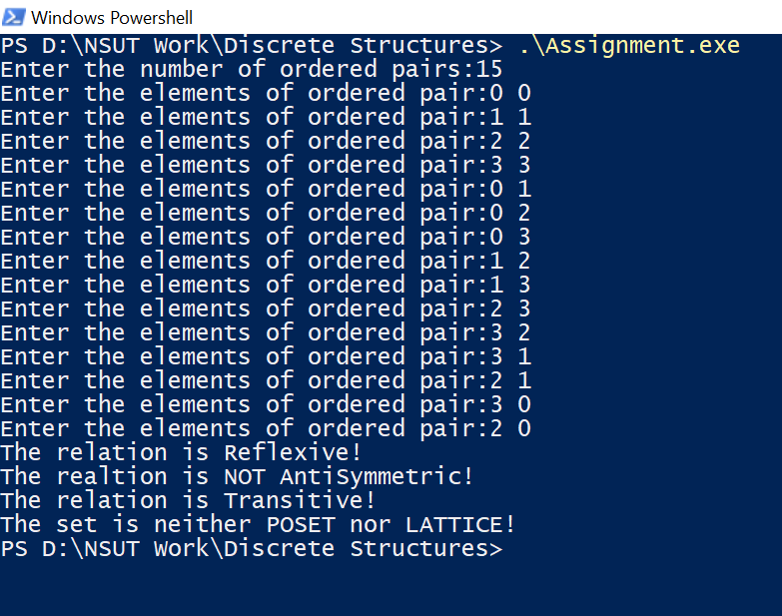

**By: Amogh Garg  
2020UCO1688  
COE-6**